**Sprint 3 Plan**

*Okinawa Memory Initiative*

*The Okinawaners*

**Sprint Completion Date:** 11/18/18

**Revision:** 1.1

**Revision Date:** 11/18/18

**Goal:**

We want to have a working website where users can view our database of documents on Okinawa. Furthermore, since the skeleton for the frontend is complete, we now want to flesh out the pages so that the team can focus more on the backend portion of the project, and polish the website.

**User Story 1:**

As a User, I want to be able to hover over special selected documents in the Vault Page, so that the content is interactive. I also want to able to connect the general Vault Page with separate Videos, Articles, and Gallery pages for more of the respective content.

Task 1.1: Create the hover-on article effect using Grid/box layout (1 hour)

Task 1.2: Create View More feature (1 hour)

**User Story 2:**

As a user, I want to be able to see a list of more pictures, videos, and articles when I click View More in the Vault page, respectively linking to correct pages.

Task 2.1: Create a list of pictures, videos and articles linked from the backend that can be accessed from the front end. (1.5 hours)

Task 2.2: Dynamically display a preview of the pictures, videos, and articles from the lists (show and link the four newest items directly from the Vault page). (2 hours)

Task 2.3: Link the View More options to the respective Details page. (1 hour)

**User Story 3:**

As a user, I want to be able to access the appropriate YouTube Videos within the Vault page so that I may view the desired videos about Okinawan history.

Task 3.1: Have the site dynamically parse the given links from the backend, and display Youtube videos within our Youtube page. (3 hour)

**User Story 4:**

As a user, I want to be able to interact with a map of Okinawa on the Home page, so that I can get a better sense of the island's geography, and history.

Task 4.1: Create a map feature that would display a map of Okinawa and show source locations of relevant articles. (3 hours)

**User Story 5:**

As a user, I want to able to use the Documents pages at its full capacity, so that I would be able to see the historical archive of Okinawa in an effective way.

Task 5.1: Make the Documents page work dynamically where the documents are retrieved from the database and displayed on the user interface (1 hour)

**User Story 6:**

As a user, I want to be able to see the documents from the database, so that I can access the documents selected.

Task 6.1: Put documents into Django Database ( 3 hours )

Task 6.2: Write a get/query function in the backend to get pictures ( 8 hours )

Task 6.3: Write a get API for FE developers to get pictures ( 8 hours )

**Task Assignments:**

Kevin Tran: (Task 6.1, 6.2, 6.3)

Jeff Liao: (Task 6.1, 6.2, 6.3)

Tina Peng: (Task 2.1, 2.2, 2.3)

Wellford Chan: (Task 6.1, 6.2, 6.3, Task 4.1, Task 5.1)

Ankita Upadhyay: (Task 3.1)

Alfred George Francisco Milan III: (Task 1.1, 1.2; User Story 5: Task 5.1)

**Team Roles:**

Kevin Tran: Project Owner, {UI design, Frontend}

Jeff Liao: Backend, {Frontend}

Tina Peng: Frontend {UI design, Backend}

Wellford Chan: Scrum Master { Front End/ Back End Integration }

Ankita Upadhyay: Backend {Frontend}

Alfred George Francisco Milan III: Full Stack {Backend}

**Initial Scrum Board:**

|  |  |  |  |
| --- | --- | --- | --- |
| Stories | ToDo | In Progress | Done |
| As a user, I want to be able to use the website and to be able to see the following pages: Home, About, Vault, Documents, Events, Donate, Gail Project, Login. | **Task 5.1:** Make the Documents page work dynamically where the documents are sorted from the database and displayed on the user interface (2 hours) | **Task 1.3:** Create the hover-on article effect using Grid/box layout (1 hour)  **Task 1.5:** Create View More feature (1 hour)  **Task 2.1:** Create parsing feature that would allocate the right image with its respective description. (2 hours)  **Task 2.2:** Dynamically display a preview of the pictures, videos, and articles from the lists (show and link the four newest items directly from the Vault page). (2 hours)  **Task 2.3:** Link the View More options to the respective Details page. (1 hour)  **Task 3.2:** Have the Youtube videos dynamic and have the appropriate ones show up (3 hour)  **Task 4.2:** Create map feature that would display interactive Map of Okinawa (3 hours) | **Task 1.1:** Create the jumbotron (1 hour)  **Task 1.4:** Create featured article section with accompanying Subscribe section (1 hour)  **Task 1.2:** Create the Videos, Article, and Gallery subsections (1 hour)  **Task 2.2:** Create layout where multiple article posts can be displayed on one screen. (1 hour)  **Task 3.1:** Create separate Video page that would display Youtube videos regarding appropriate content regarding The Battle of Okinawa, Okinawa as a U.S. Base, and its consequences. (2 hours)  **Task 4.1:** Create Home Page (1 hour)  **Task 4.3:** Write Description and Introduction for the website (<1 hour) |
| As a user, I want to be able to see the documents from the database | **Task 6.3:** Write a get API for FE developers to get pictures ( 8 hours ) | **Task 6.1:** Put documents into Amazon S3 ( 3 hours )  **Task 6.2:** Write a get/query function in the backend to get pictures from S3 ( 8 hours ) |  |

**Initial Burn Up Chart:**

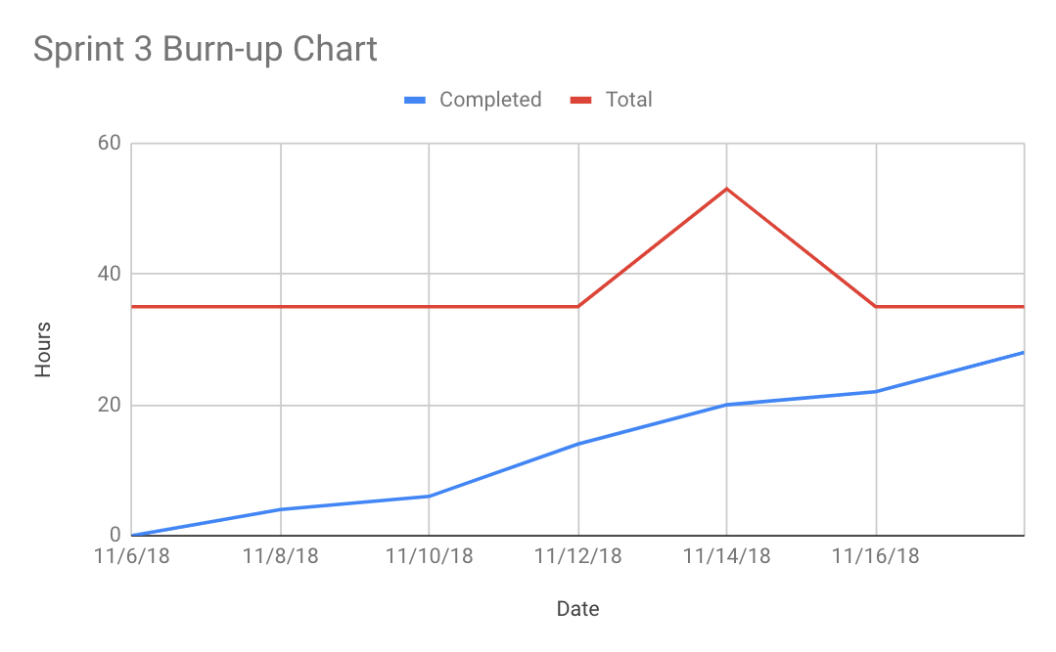

**Scrum Times:**

Tuesday 3:30pm

Thursday 2:00pm

Sunday 7:00pm